Functional Model
Smart Audio Travel Companion
By
Srinivas Pulukuri

1. Use Case Diagram
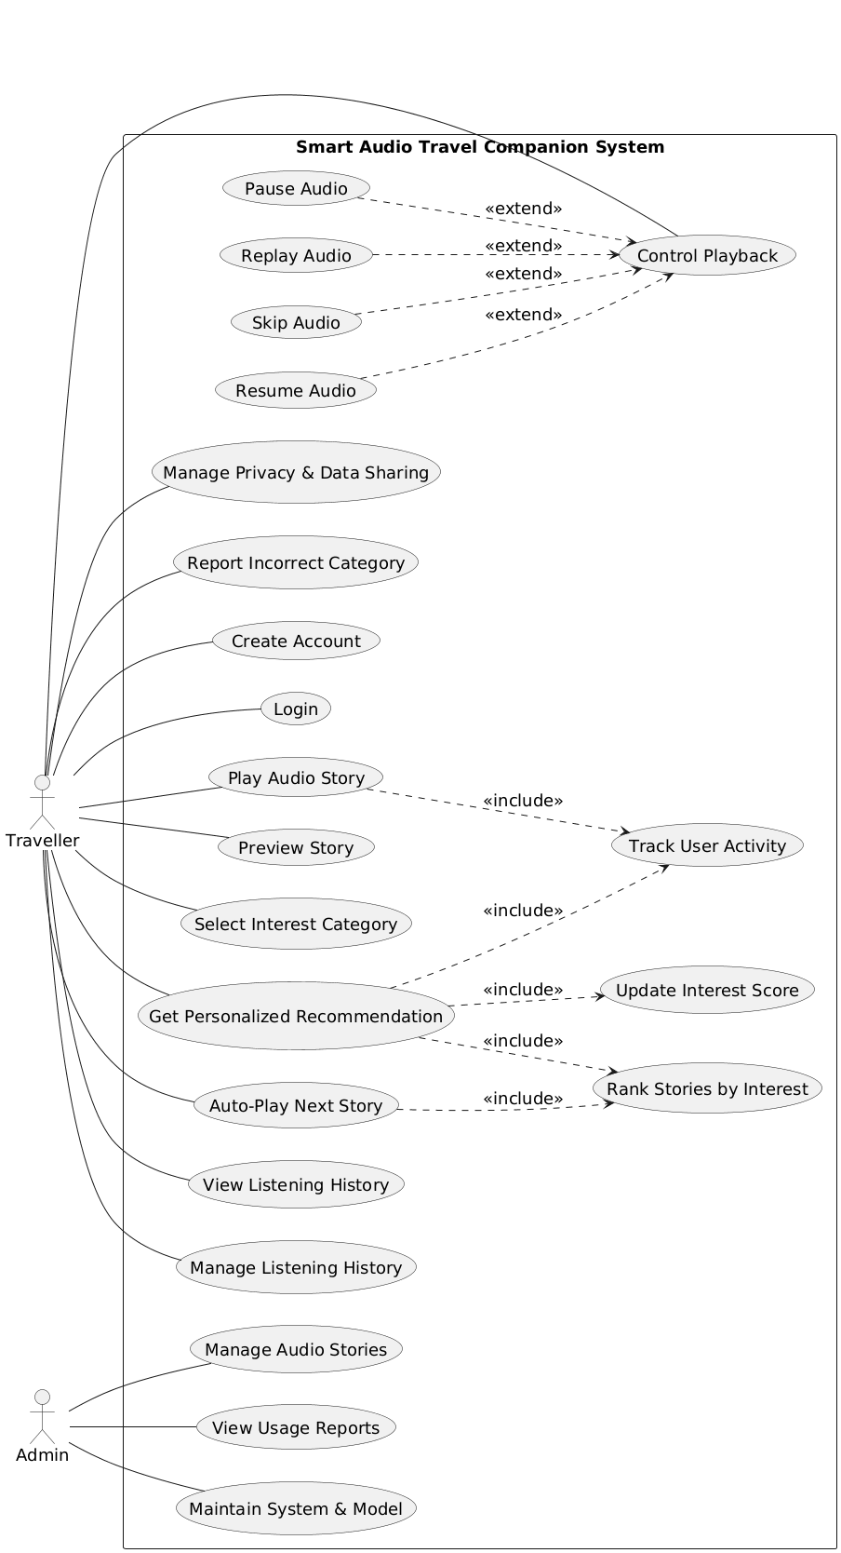
Figure.1 Use Case Diagram

2. Use Case Description

1. Create Account
Field | Description
Use Case Number | 1
Use Case Name | Create Account
Primary Actor | Traveller
Trigger | Traveller selects the option to create a new account on the system homepage.
Pre-conditions | Traveller is not currently logged into the system. The system is available through a web browser. The privacy notice is accessible.
Post-conditions | A new traveller account is created and stored securely in the system. The traveller is informed that the account creation was successful and can proceed to log in.
Normal Flow | 1. Traveller opens the Smart Audio Travel Companion website.  2. Traveller selects “Create Account.”  3. System displays the registration form and privacy notice.  4. Traveller enters required details such as username and password.  5. Traveller reviews and agrees to the data use notice.  6. System validates the input values.  7. System securely stores the new account information.  8. System confirms successful account creation.
Exception Flows | 1. If required fields are missing, the system highlights the missing information and requests completion.  2. If the chosen username already exists, the system asks the traveller to select a different username.  3. If the system is temporarily unavailable, the account is not created and an error message is shown.
User Requirement Reference | Traveller opens personal account; Traveller agrees to data use notice; Sign-in data must travel through secure channels.

2. Login
Field | Description
Use Case Number | 2
Use Case Name | Login
Primary Actor | Traveller
Trigger | Traveller selects the login option and submits login credentials.
Pre-conditions | Traveller has an existing registered account. The system is online and reachable through a web browser.
Post-conditions | Traveller is authenticated and gains access to the system dashboard and audio features.
Normal Flow | 1. Traveller enters username and password on the login page.  2. System securely transmits the credentials for validation.  3. System verifies the credentials against stored account data.  4. System grants access and displays the main dashboard to the traveller.
Exception Flows | 1. If credentials are incorrect, the system displays an error message and allows retry.  2. If the system cannot reach the authentication service, the login attempt fails with a service error message.
User Requirement Reference | Traveller enters platform using login; Sign-in data must travel through secure channels.

3. Play Audio Story
Field | Description
Use Case Number | 3
Use Case Name | Play Audio Story
Primary Actor | Traveller
Trigger | Traveller selects an audio story to listen to.
Pre-conditions | Traveller is logged in. At least one audio story is available in the system. Network connectivity is available.
Post-conditions | The selected audio story begins playback. User listening activity is tracked for learning and recommendation purposes.
Normal Flow | 1. Traveller browses or receives a recommended list of stories.  2. Traveller selects a story to play.  3. System loads the audio stream.  4. System starts audio playback.  5. System begins tracking listening time and user actions for learning purposes.
Exception Flows | 1. If the audio file cannot be loaded, the system displays an error and suggests trying another story.  2. If the network connection is slow, the system displays a loading indicator until playback starts.
User Requirement Reference | Traveller starts audio for current place; System records listening time; Audio must play clearly on low internet speeds.

4. Preview Story
Field | Description
Use Case Number | 4
Use Case Name | Preview Story
Primary Actor | Traveller
Trigger | Traveller selects the preview option for a story before listening fully.
Pre-conditions | Traveller is logged in. Preview clips are available for the selected story.
Post-conditions | A short preview clip of the selected story is played to the traveller.
Normal Flow | 1. Traveller views a list of available or recommended stories.  2. Traveller selects the preview option for a specific story.  3. System loads and plays a short preview clip.  4. Traveller decides whether to play the full story or choose another one.
Exception Flows | 1. If a preview clip is not available, the system displays a message indicating that preview is unavailable.  2. If the preview fails to load, the system prompts the traveller to try again later.
User Requirement Reference | System presents short previews to engage user; Traveller views short preview clip.

5. Select Interest Category
Field | Description
Use Case Number | 5
Use Case Name | Select Interest Category
Primary Actor | Traveller
Trigger | Traveller opens interest settings and selects preferred story categories.
Pre-conditions | Traveller is logged in. Interest categories such as history, nature, culture, and legends exist in the system.
Post-conditions | Selected interest categories are saved and used to influence future recommendations.
Normal Flow | 1. Traveller opens interest preference settings.  2. System displays available interest categories.  3. Traveller selects or updates preferred categories.  4. System saves the updated interest preferences.
Exception Flows | 1. If saving preferences fails, the system displays an error and retains the previous settings.
User Requirement Reference | Traveller chooses story type; Traveller updates interest options.

6. Get Personalized Recommendation
Field | Description
Use Case Number | 6
Use Case Name | Get Personalized Recommendation
Primary Actor | Traveller
Trigger | Traveller requests personalized recommendations or opens the recommendations view.
Pre-conditions | Traveller is logged in. Some listening activity or interest preferences exist.
Post-conditions | A ranked list of personalized story recommendations is displayed to the traveller.
Normal Flow | 1. Traveller requests personalized recommendations.  2. System retrieves recent user activity and preferences.  3. System converts activity data into numeric features.  4. System updates the traveller’s interest score using the learning model.  5. System ranks available stories based on predicted interest level.  6. System displays the personalized recommendation list.
Exception Flows | 1. If insufficient data exists for personalization, the system displays general or default recommendations.  2. If the recommendation process fails, the system informs the traveller and retries later.
User Requirement Reference | System converts actions into numeric values; System runs Random Forest model; System orders stories by predicted interest level; Stories played based on user preferences.

7. Auto-Play Next Story
Field | Description
Use Case Number | 7
Use Case Name | Auto-Play Next Story
Primary Actor | Traveller
Trigger | The current audio story finishes playing.
Pre-conditions | Traveller is logged in and listening to an audio story. At least one recommended story is available.
Post-conditions | The next recommended story begins playing automatically.
Normal Flow | 1. Current story finishes playback.  2. System retrieves the next highest-ranked story.  3. System automatically starts playing the next story.  4. System begins tracking activity for the new story.
Exception Flows | 1. If no suitable next story is available, the system stops playback and displays a message.  2. If auto-play is disabled by the traveller, the system waits for manual selection.
User Requirement Reference | Traveller receives next story automatically; System orders stories by predicted interest level.

8. View Listening History
Field | Description
Use Case Number | 8
Use Case Name | View Listening History
Primary Actor | Traveller
Trigger | Traveller selects the option to view listening history.
Pre-conditions | Traveller is logged in. Listening records exist in the system or the system can show an empty history view.
Post-conditions | The traveller’s listening history is displayed on the screen.
Normal Flow | 1. Traveller opens the listening history page.  2. System retrieves listening records for the traveller.  3. System displays a list of previously played, skipped, or completed stories with basic details.
Exception Flows | 1. If no listening history exists, the system displays a message indicating that no records are available.  2. If the history data cannot be retrieved, the system displays an error message.
User Requirement Reference | Traveller opens listening history; Listening activity must be stored for later viewing.

9. Manage Listening History
Field | Description
Use Case Number | 9
Use Case Name | Manage Listening History
Primary Actor | Traveller
Trigger | Traveller selects options to manage or clear listening history.
Pre-conditions | Traveller is logged in. Listening history exists in the system.
Post-conditions | Selected listening records are cleared or updated based on the traveller’s action.
Normal Flow | 1. Traveller opens listening history management options.  2. System displays available management actions such as clear history.  3. Traveller selects records to clear or chooses to clear all history.  4. System confirms the action.  5. System updates the stored listening records.
Exception Flows | 1. If the update fails due to a system issue, the system displays an error and keeps the original records unchanged.
User Requirement Reference | Traveller clears listening history; Listening activity must be kept only for a limited period.

10. Manage Privacy & Data Sharing
Field | Description
Use Case Number | 10
Use Case Name | Manage Privacy & Data Sharing
Primary Actor | Traveller
Trigger | Traveller opens privacy and data sharing settings.
Pre-conditions | Traveller is logged in. Privacy policy and data sharing options are available.
Post-conditions | Updated privacy and data sharing preferences are saved in the system.
Normal Flow | 1. Traveller opens privacy settings.  2. System displays the privacy message and data sharing options.  3. Traveller reviews the information and updates preferences.  4. System saves the updated privacy settings.  5. System confirms that the changes were applied.
Exception Flows | 1. If saving preferences fails, the system informs the traveller and keeps previous settings.
User Requirement Reference | Traveller reads privacy message; Traveller changes data sharing setting; The system must protect user privacy.

11. Report Incorrect Category
Field | Description
Use Case Number | 11
Use Case Name | Report Incorrect Category
Primary Actor | Traveller
Trigger | Traveller flags a story that is assigned to an incorrect category.
Pre-conditions | Traveller is logged in. A story with category information is being viewed or played.
Post-conditions | The incorrect category report is recorded and made available for admin review.
Normal Flow | 1. Traveller selects the option to report an incorrect category.  2. System displays a simple reporting form.  3. Traveller submits the report.  4. System records the report for administrative review.
Exception Flows | 1. If report submission fails, the system displays an error message and allows retry.
User Requirement Reference | Traveller flags wrong story category; Admin can review content issues.

12. Control Playback
Field | Description
Use Case Number | 12
Use Case Name | Control Playback
Primary Actor | Traveller
Trigger | Traveller interacts with playback controls during audio playback.
Pre-conditions | An audio story is currently playing or paused. Traveller is logged in.
Post-conditions | The playback state is updated based on the selected control action.
Normal Flow | 1. Traveller selects a playback control option.  2. System processes the selected control.  3. System updates playback state.  4. System records the playback action for learning purposes.
Exception Flows | 1. If playback control fails to respond, the system retries the action and informs the traveller if the issue persists.
User Requirement Reference | Traveller pauses playing audio; Traveller continues paused audio; Traveller skips current audio story; Traveller replays selected audio story.

13. Pause Audio
Field | Description
Use Case Number | 13
Use Case Name | Pause Audio
Primary Actor | Traveller
Trigger | Traveller selects the pause option while an audio story is playing.
Pre-conditions | An audio story is currently playing. Traveller is logged in.
Post-conditions | Audio playback is paused and the current playback position is saved.
Normal Flow | 1. Traveller selects pause.  2. System pauses audio playback.  3. System stores the current playback position.
Exception Flows | 1. If pausing fails, the system displays an error message and continues playback.
User Requirement Reference | Traveller pauses playing audio.

14. Resume Audio
Field | Description
Use Case Number | 14
Use Case Name | Resume Audio
Primary Actor | Traveller
Trigger | Traveller selects the resume option after pausing audio playback.
Pre-conditions | An audio story is paused. Traveller is logged in.
Post-conditions | Audio playback resumes from the last paused position.
Normal Flow | 1. Traveller selects resume.  2. System resumes playback from the saved position.  3. System continues tracking listening activity.
Exception Flows | 1. If resuming fails, the system displays an error message and keeps playback paused.
User Requirement Reference | Traveller continues paused audio.

15. Skip Audio
Field | Description
Use Case Number | 15
Use Case Name | Skip Audio
Primary Actor | Traveller
Trigger | Traveller selects the skip option while an audio story is playing.
Pre-conditions | An audio story is currently playing. Traveller is logged in.
Post-conditions | The current story stops and the system prepares the next available or recommended story.
Normal Flow | 1. Traveller selects the skip option.  2. System stops the current audio playback.  3. System records the skip action as part of listening behavior.  4. System prepares the next story for playback.
Exception Flows | 1. If skipping fails, the system continues playback and displays an error message.
User Requirement Reference | Traveller skips current audio story; System records skip count.

16. Replay Audio
Field | Description
Use Case Number | 16
Use Case Name | Replay Audio
Primary Actor | Traveller
Trigger | Traveller selects the replay option for the current or previously played story.
Pre-conditions | Traveller is logged in. A story has been played previously.
Post-conditions | The selected audio story starts playing again from the beginning.
Normal Flow | 1. Traveller selects replay.  2. System reloads the selected story.  3. System starts playback from the beginning.  4. System records the replay action for learning purposes.
Exception Flows | 1. If the story cannot be replayed, the system displays an error message and suggests selecting another story.
User Requirement Reference | Traveller replays selected audio story; System records replay count.

17. Track User Activity
Field | Description
Use Case Number | 17
Use Case Name | Track User Activity
Primary Actor | System (triggered by Traveller actions)
Trigger | Traveller performs listening actions such as play, pause, skip, replay, or completes a story.
Pre-conditions | Traveller is logged in and interacting with audio content.
Post-conditions | User activity data such as listening time, skip count, replay count, and completion status is recorded.
Normal Flow | 1. Traveller performs an audio-related action.  2. System captures the action details.  3. System stores activity data securely.
Exception Flows | 1. If activity tracking fails, the system logs the error and continues playback without tracking.
User Requirement Reference | System records listening time, skip count, replay count, and completion; Listening activity must be stored securely.

18. Update Interest Score
Field | Description
Use Case Number | 18
Use Case Name | Update Interest Score
Primary Actor | System (triggered by recommendation request or session end)
Trigger | System initiates interest update after collecting user activity data.
Pre-conditions | User activity data exists. Learning model is available.
Post-conditions | The traveller’s interest profile is updated based on recent behavior.
Normal Flow | 1. System retrieves recent user activity records.  2. System converts actions into numeric feature values.  3. System applies the learning model to update interest scores.  4. System stores the updated interest profile.
Exception Flows | 1. If the learning model is unavailable, the system uses the previous interest score and logs the issue.
User Requirement Reference | System converts actions into numeric values; System runs Random Forest model; System refreshes interest score after session ends.

19. Rank Stories by Interest
Field | Description
Use Case Number | 19
Use Case Name | Rank Stories by Interest
Primary Actor | System (triggered by recommendation or auto-play request)
Trigger | System needs to prepare a ranked list of stories for recommendation or auto-play.
Pre-conditions | Updated interest scores exist. A list of available stories exists.
Post-conditions | Stories are ranked based on predicted interest level for the traveller.
Normal Flow | 1. System retrieves the updated interest profile.  2. System evaluates available stories against the interest profile.  3. System orders stories from highest to lowest predicted interest.  4. System provides the ranked list to the recommendation or auto-play process.
Exception Flows | 1. If ranking fails, the system falls back to a default ordering of stories.
User Requirement Reference | System orders stories by predicted interest level; Stories are played based on user preferences.

20. Manage Audio Stories
Field | Description
Use Case Number | 20
Use Case Name | Manage Audio Stories
Primary Actor | Admin
Trigger | Admin selects options to manage audio content.
Pre-conditions | Admin is authenticated with appropriate permissions.
Post-conditions | Audio stories are uploaded, updated, categorized, or removed as requested.
Normal Flow | 1. Admin opens the content management area.  2. Admin uploads new audio files or selects existing ones to edit.  3. Admin updates story details and category tags.  4. Admin removes inactive stories if needed.  5. System saves the changes and updates the content library.
Exception Flows | 1. If an upload fails, the system displays an error and requests retry.  2. If the admin lacks permission, access is denied.
User Requirement Reference | System admin uploads new audio files; edits story details; assigns story category tags; removes inactive stories.

21. View Usage Reports
Field | Description
Use Case Number | 21
Use Case Name | View Usage Reports
Primary Actor | Admin
Trigger | Admin requests usage statistics or downloads reports.
Pre-conditions | Admin is logged in. Usage data exists in the system.
Post-conditions | Usage reports are displayed on screen or downloaded by the admin.
Normal Flow | 1. Admin opens the usage reports section.  2. System generates usage statistics such as play counts and engagement metrics.  3. System displays the report.  4. Admin optionally downloads the usage summary.
Exception Flows | 1. If report generation fails, the system displays an error and logs the issue.
User Requirement Reference | System admin reviews story play counts; downloads usage summary.

22. Maintain System & Model
Field | Description
Use Case Number | 22
Use Case Name | Maintain System & Model
Primary Actor | Admin
Trigger | Admin performs maintenance or monitoring activities.
Pre-conditions | Admin is authenticated with maintenance permissions. System is operational.
Post-conditions | System health is checked and learning model maintenance tasks are completed.
Normal Flow | 1. Admin opens system maintenance tools.  2. Admin checks service health and logs.  3. Admin reviews learning model logs.  4. Admin schedules model training or updates.  5. Admin manages user permissions or resets access if required.  6. System records all maintenance actions in the review log.
Exception Flows | 1. If a maintenance task fails, the system displays an error and records the failure for later review.
User Requirement Reference | System admin checks service health; reviews learning model logs; schedules model training; manages user permissions; resets user access; system changes logged.

3. Activity Diagram
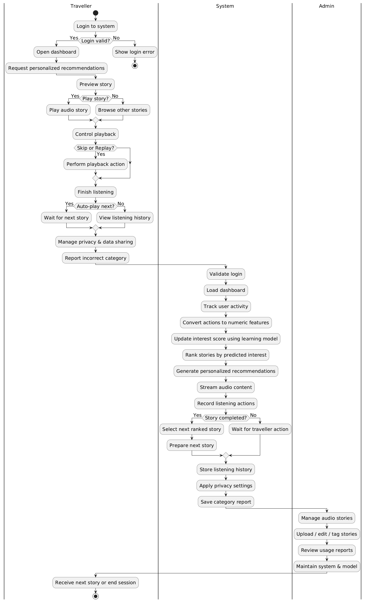
Figure.2 Activity Diagram

